<https://digitalmarketers.org/pages/dmo-advanced>

<https://marketinganalyticssummit.com/>

**Calls to action:**

Register

Join

Sign up for newsletter

**Goals:**

Find the agenda

Venue

**Registration Form:**

**Things to do:**

Link registration forms/register now buttons

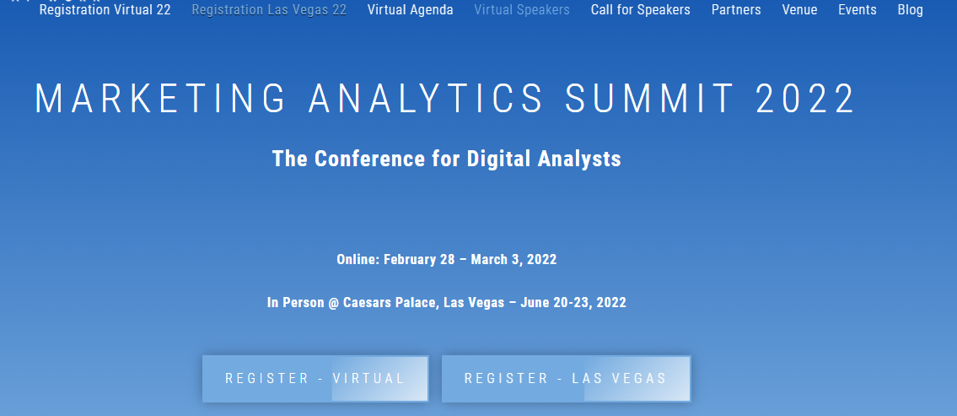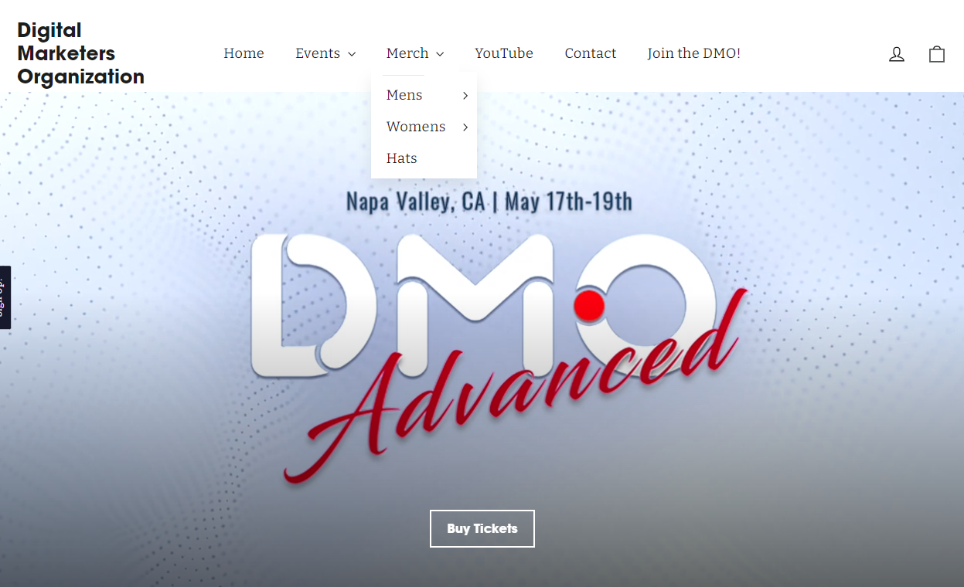

Register: Virtual

Register: In-Person

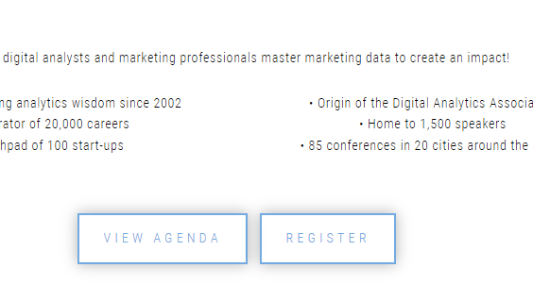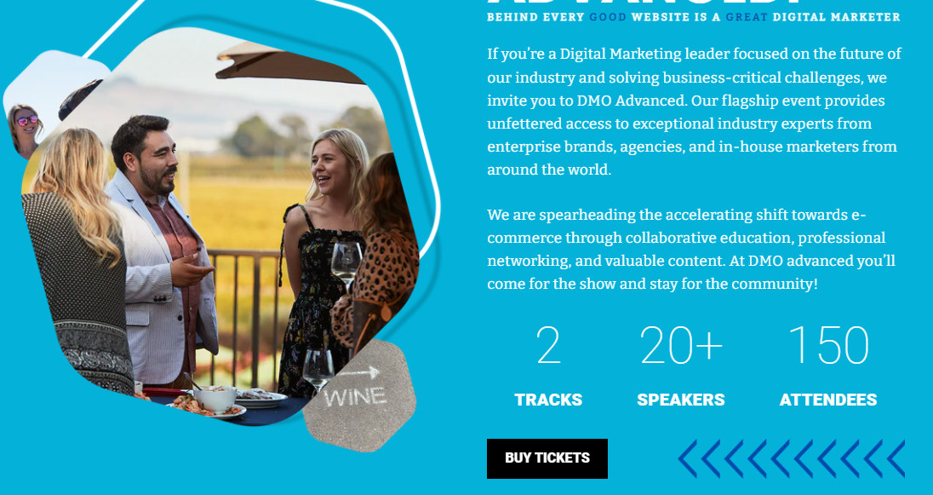



* + **Benefits of attending**
    - What you’ll learn?
    - What can you expect?
    - Why go?
    - Who should go?
    - Who’s going to be there?

Connect with 100+ physicians, environmental experts, and patients for two immersive days focused on addressing the challenges and best practices of identifying and treating Chronic Inflammatory Response Syndrome (CIRS)

Our conference is designed to help you:

* Build connections with leaders in the medical and environmental industries
* Stay current with emerging trends and best practices in identification and treatment of mold related illnesses
* Understand the importance of
* Join ***the mission*** to serve people impacted by mold related illnesses, specifically Chronic Inflammatory Response Syndrome (CIRS).

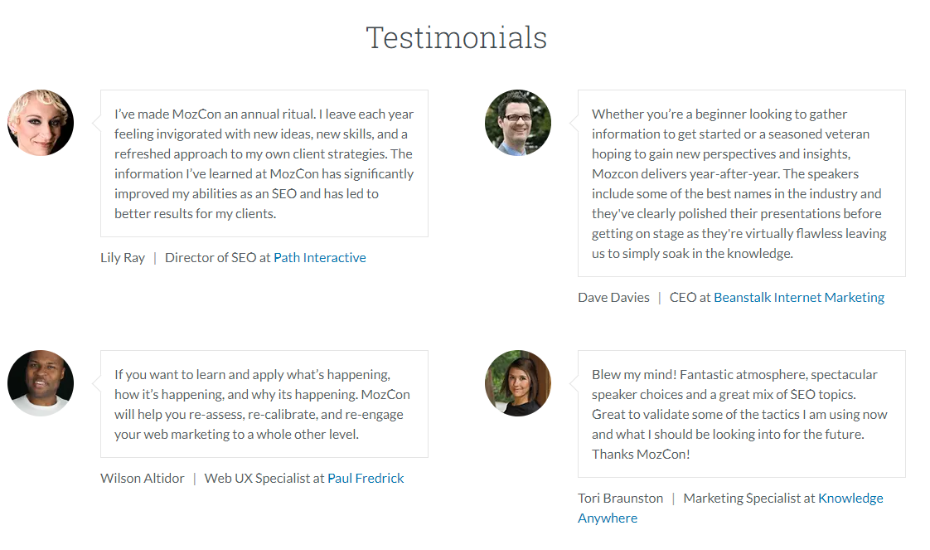Our 2022 Exhibitors

* + **The Venue**
    - Venue
    - Hotel

**Footer:**

WORKING WITH US

Contact Us

About Us

Advertise/Exhibitors

**Content needed:REGISTER**

Speaker headshots & bios

**Benefits of Sponsorship Partner**

1. Ability to promote brand and sell product and services in a variety of ways – at in-person conference with pop up banners/signage, exhibit table, and throughout the next 12 months through logo and banner ads, video content on CIRSx website, conference communications, and our growing online Membership Library
2. Ability to speak/present in front of in-person meeting attendees, promoting product and services while showing scientific evidence to support
3. Ability to ***join the mission*** by meeting and networking with top physicians of their field and patients affected by CIRS
4. Ability to support and be a part of a “Good Cause” in the medical space serving patients impacted by mold related illnesses, specifically Chronic Inflammatory Response Syndrome (CIRS)
5. Access to CIRSx Medical Glossary